SCHOOL OF CYBERSECURITY
NAME: OBASI CHARLES CHIDOZIE
ID: VEPH/20B/CY053
TASK: TASK 20A (LESSON 20)

Technical Cyber security Report

Analysis Using METASPLOIT for a network scan of the target system’s IP address utilizing Nmap with the -sC, -sV, and -vv options

By

Cyber Security Personnel : OBASI CHARLES CHIDOZIE

Date : 05/04/2025

Stakeholders : Mentor Ibukun
REPORT OUTLINE
- Executive Summary
- Brief overview of the entire report
- Key findings and recommendations
- Background and purpose
- Scope/aim & Objectives of the report
- Objectives of tools used ( Nmap, Metasploit)
- Methodology
- Step-by-step process followed
- Command-line options used (-sC -sV -vv, etc.)
- Tools configuration and execution
- Findings and Analysis
- Behavioral Analysis
- Observations during scanning
- Risk and Impact Assessment
- Potential impacts on systems or networks
- Recommendations
- Immediate Remediation Actions
- Mitigation Strategies
- Conclusion
- Summary of findings

1. Executive Summary
- Overview:
  - The analysis with METASPLIOT was conducted as part of an investigation to detect and identify vulnerabilities in the target systems network. The tool was used to scan the target system IP address and ports in the network utilizing Nmap with the -sC, -sV, and -vv options.
  - -sC command is to verify scripts running in the IP address if it pass through host and networks
  - -sV command checks for the version of service running through the ports.
  - -vv command gives a well detailed report on the IP address.
- Key Findings:
Key Findings from Metasploit utilizing Nmap Scan with the -sC -sV -vv options on Target IP: 192.168.0.100
- 8 Open Ports Identified
- Service and Version Detection: Using the -sV flag, service versions were accounted for.
- Default Script Results (-sC): The default Nmap scripts provided additional details
- Detailed Verbose Output (-vv): The scan produced highly detailed feedback,
- Data Imported into Metasploit: Results were stored in Metasploit’s database, enabling streamlined pivoting to exploitation or vulnerability validation using Metasploit modules.
- No potential Vulnerabilities detected. Based on version detection and default scripts on the target IP Address no potential vulnerabilities or misconfigurations were flagged. These findings form the foundation for planning targeted exploitation attempts, reporting risks to stakeholders, or taking remediation actions.

2. Background and Objectives
- Project Context:
  - The project aimed to assess the security posture of the network and to detect and identify vulnerabilities in the target system. Nmap through METASPLOIT was employed as a tool to scan the IP address and identify open ports in a network and to detect installed applications
  - Determine service versions to match with known vulnerabilities.
  - Run default scripts to scan for possible vulnerabilities.

- Objective of the Tool Use:
  - METASPLOIT was utilized to detect and identify vulnerabilities in the target systems network. The tool was used to scan the target system IP address and ports in the target system network utilizing Nmap with the -sC, -sV, and -vv options by running it in a Kali Linux virtual machine.
  - Metasploit automatically adds host data to the project during a discovery scan, enabling a better understanding of the network topology and target characteristics.

3. Methodology

3.1 Tool Configuration
- METASPLOIT Nmap Configuration:
Setup Steps:
    - Open Kali Linux Virtual Machine.
    - Open the terminal and use the command sudo su to go to the root
    - Launch metasploit using the msfconsole command
    - Used the command msfdb init to start and initialize the database.
    - Find the Ip address by opening the command prompt on windows and use the command ipconfig to get IP address
    - Run the Nmap Scan from utilizing Metasploit with the command db_nmap -sC -sV -vv followed by the IP address (192.168.0.100)

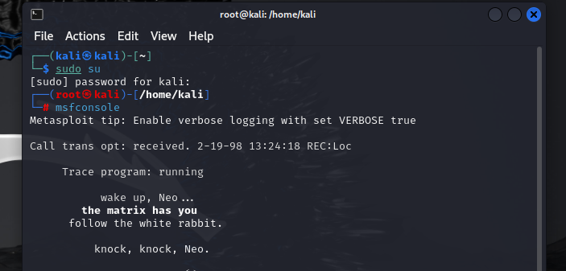
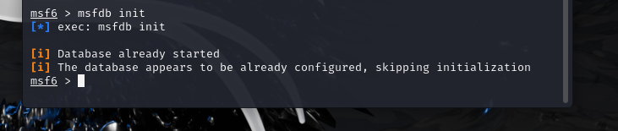
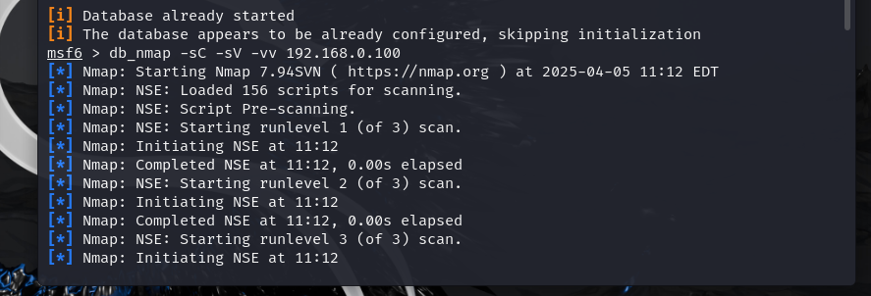
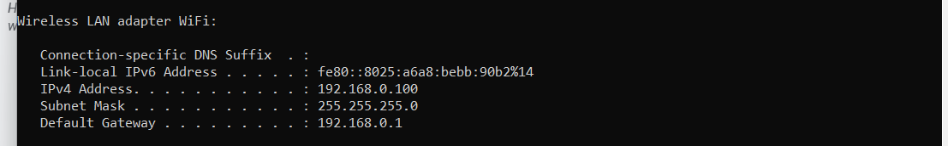

3.2 Execution Process
- File Execution in Metasploit:
The target system was scanned utilizing Nmap within the Metasploit console(db_Nmap). Upon execution, there was no presence of a malicious file detected. This is because Metasploit automatically logs and scans the targeted IP address during each analysis. This is to identify and detect presence of open ports and running scripts or services on the target system and to also scan for service versions to match with possible vulnerabilities.

3.3 Monitoring and Analysis:
- System Monitoring:
  - Metasploit uses Meterpreter for post-exploitation to capture system activities and logs.
- File system: Browse, upload/download, delete files(manual logging with spool).
- Network: View active connections (netstat), sniff traffic (sniffer).
- Registry (Windows): Read/modify registry with reg commands.
- Logging: Use spool or enable database (msfdb) to auto-log sessions, credentials, and loot.
It’s not a passive monitor but effective for manual or scripted activity tracking during exploitation.
- Network Monitoring:
  - The target system was connected to a router (Wireless Wi-Fi connection), which was indicated on the IP address scan and the tool’s integrated threat intelligence feed.

4. Findings and Analysis
  - 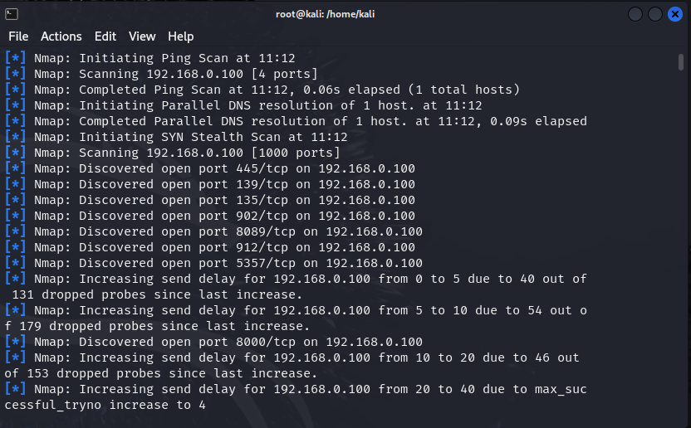
IP Address: 192.168.0.100

4.1 Observation during scanning:
- Service and Script Behavior:
- All services versions detection performed
- 156 Scripts was loaded for scanning
- All 1000 scanned ports are in ignored states
- There was no exposed service

4.2 Behavioral Analysis:
- Host Behavior
- The host responds to NSE Scripts
- Scripts pre-scanning performed
- No unauthorized access detected
- No active services detected
- No exploitations detected

4.3 Risk and Impact Assessment:
- Potential Impact:
Detecting vulnerabilities in networks requires the use of tools like Nmap and Metasploit. However, inappropriate or unauthorised use can result in ethical issues, service interruptions, and legal repercussions.

5. Recommendations

5.1 Immediate Remediation Actions:
- Update software versions to patch known vulnerabilities.
- Restrict SSH access to trusted IPs using firewall rules.
- Disable unnecessary services running on open ports.
- Maintain strict firewall rules especially for ports 445 and 8080.

5.2 Long-Term Mitigation:
- Implement Network Segmentation to limit exposure.
- Use Intrusion Detection Systems (IDS) for real-time monitoring.
- Enable Multi-Factor Authentication (MFA)
- Perform scans in a controlled or test environment
- Use non-intrusive scanning techniques

6. Conclusion
- Summary of Findings:
The Nmap-Metasploit scan successfully identified open ports, active services, their versions, and potential security risks. Several services were found running outdated versions, increasing the risk of exploitation.

Appendix: Additional Data
- Raw Logs and Tool Outputs:
- Additional Visualizations and Screenshots:
db_nmap -sC
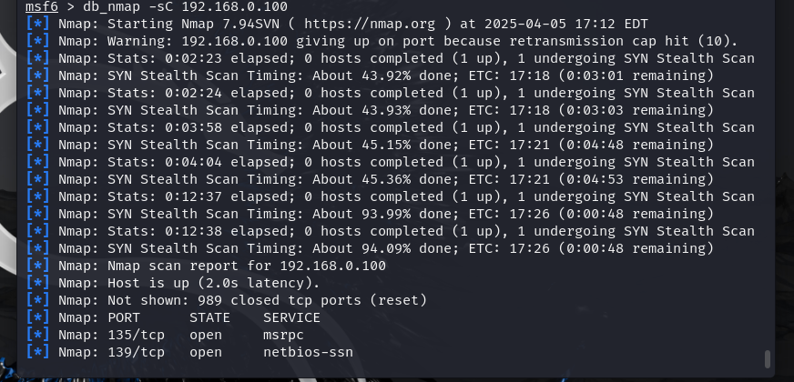
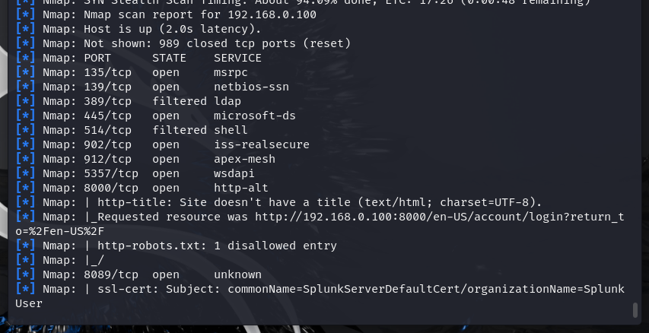
db_nmap -sV
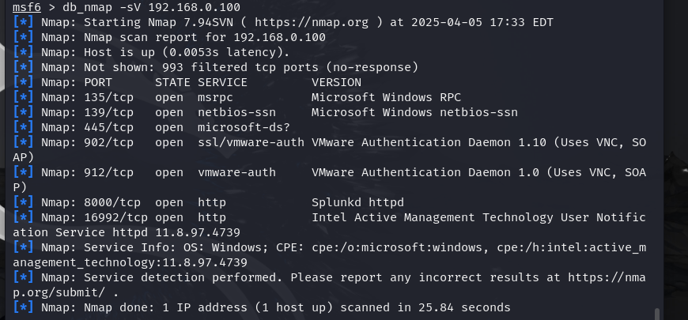
db_nmap -vv
